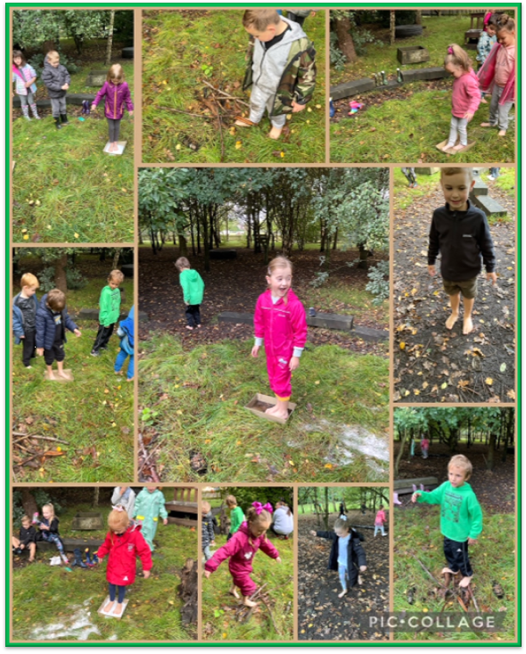

**Year 1 have been learning about the senses, in particular ‘touch’. During their lesson in the forest, they had to walk on various textures such as grass, water, sticks, snow and mud.**

**NEWSLETTER 16th SEPTEMBER 2022**

After school football

**The new after school football club on Wednesday was a huge success.**

Information for KS2 parents

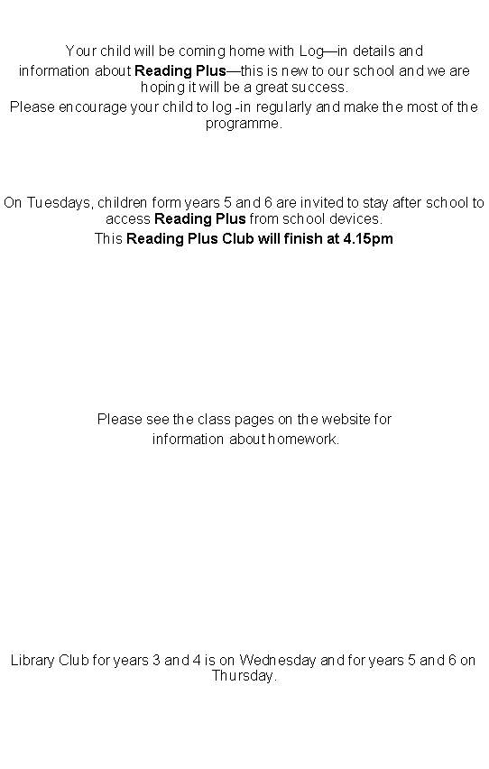

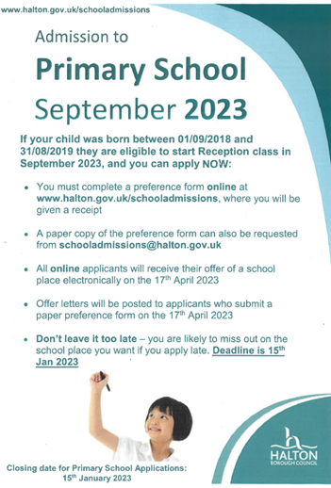

Awards—Congratulations to the following children

SMILE AWARDS



SUPERSTAR AWARDS

DOJO AWARDS

Today, Friday, 16th September is National Teaching Assistants' Day, so we want to thank our teaching assistants and recognise the valuable contribution that they make to our children. During assembly, the children shown their appreciation by giving all our assistants a huge round of applause.



Here is the link if you wish to have a look at the Wednesday Word:

<https://www.paperturn-view.com/uk/wednesday-word/trustworthy?pid=MTA101634&v=68.9>

**14th September 2022**

Week beginning 26th September Scholastic Book Fair

30th September Macmillan Coffee Morning

6th October School Census Day

7th October School photos

13th October Reception open evening

14th October Harvest Festival

19th & 20th October Parents Evening

21st October Inset Day

24th October Half Term